CS 255 System Design Document Template

This template lays out all the different sections that you need to complete for Project Two. Each section has guidance to prompt your thinking. You will need to continually reference the interview transcript as you work to make sure that you are addressing your client’s needs. There is no required length for the final document. Instead the goal is to complete each section based on what your client’s needs are. Remove this note when you are finished, and replace all bracketed text with the relevant information.

UML Diagrams

UML Use Case Diagram
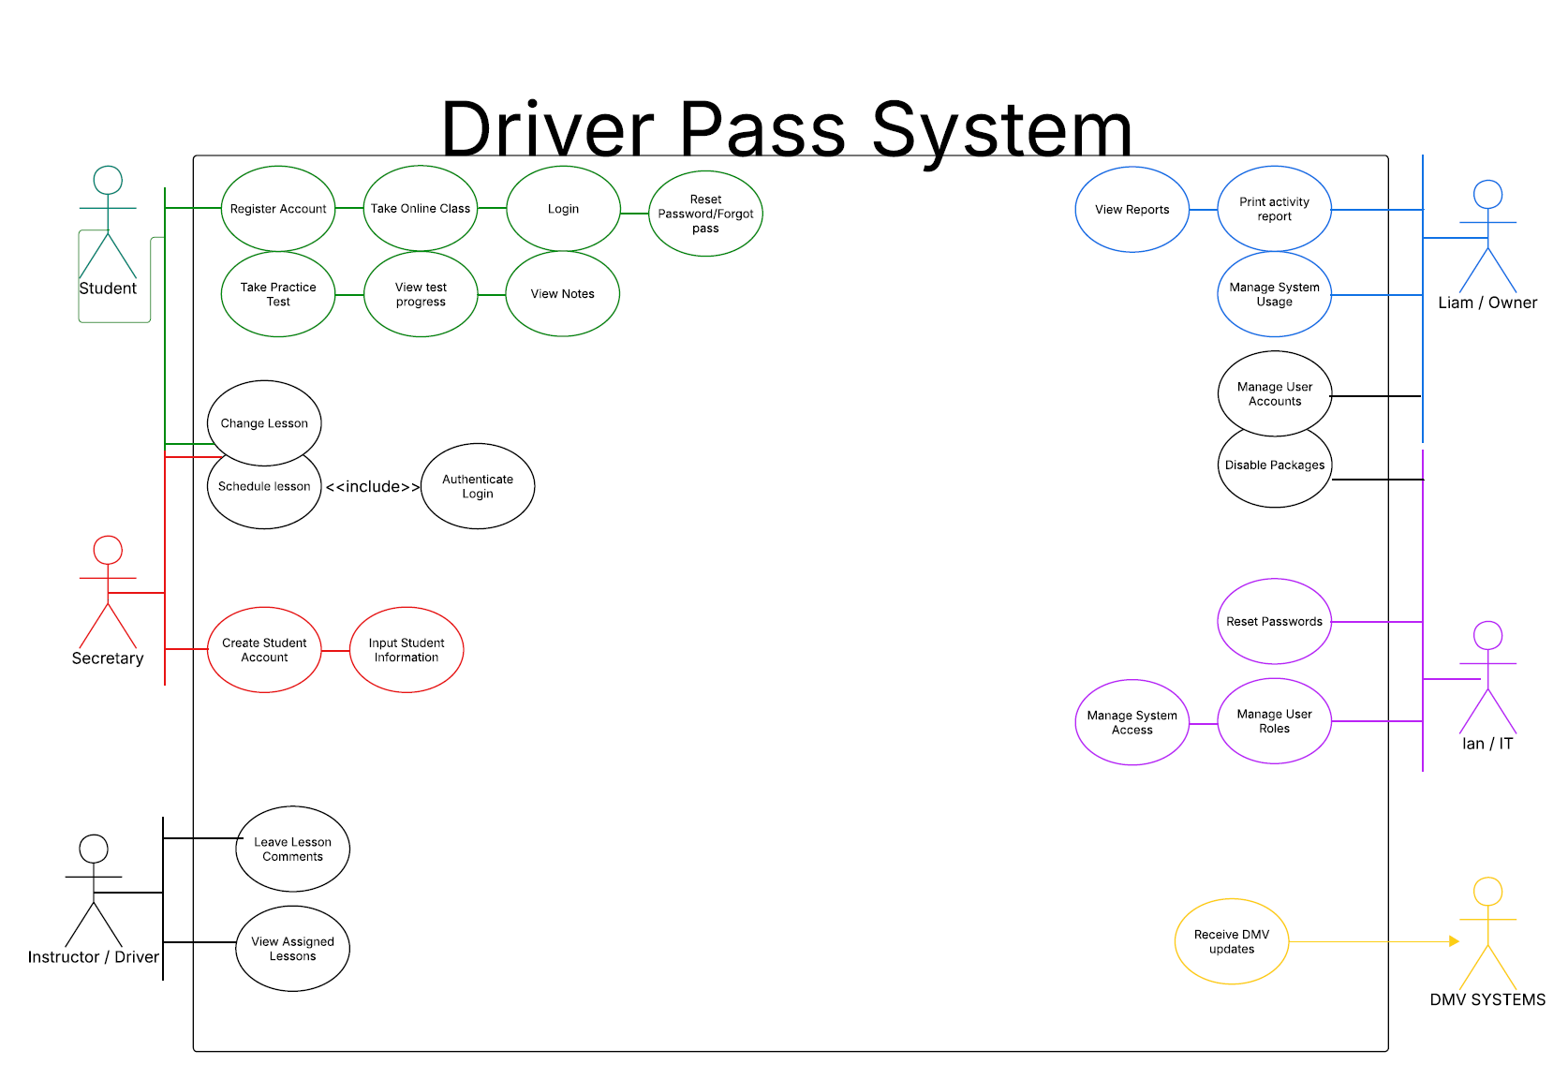

UML Activity Diagrams
[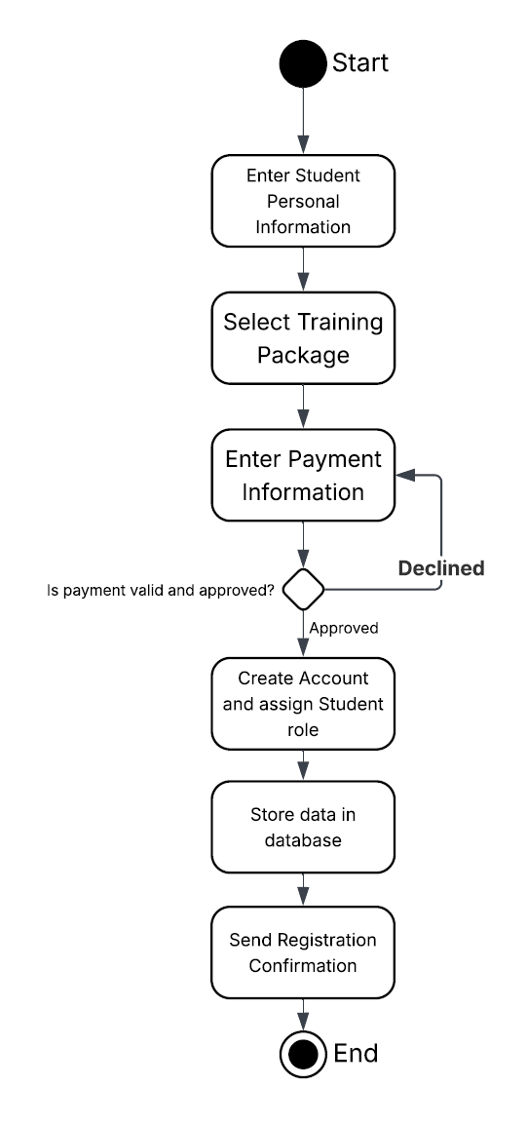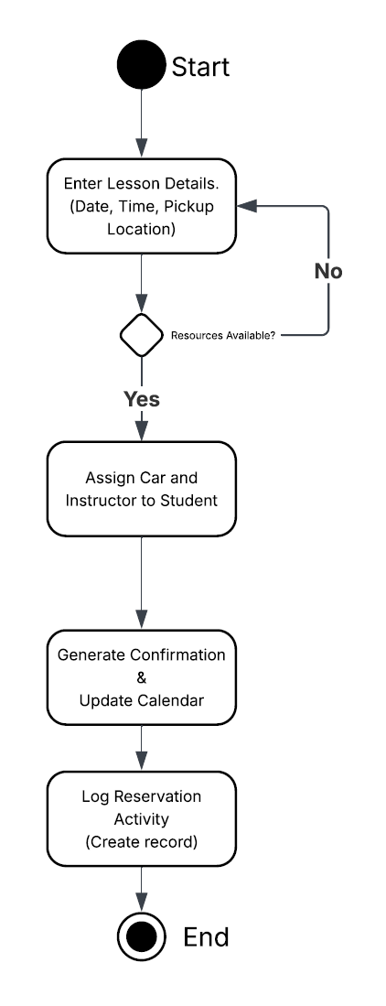.]

UML Sequence Diagram
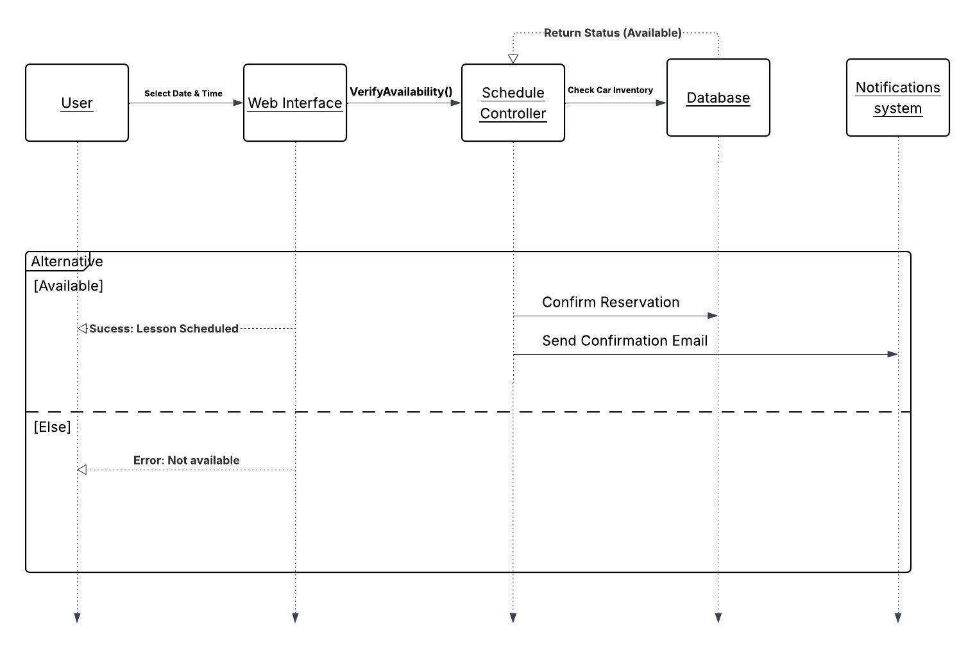

UML Class Diagram
[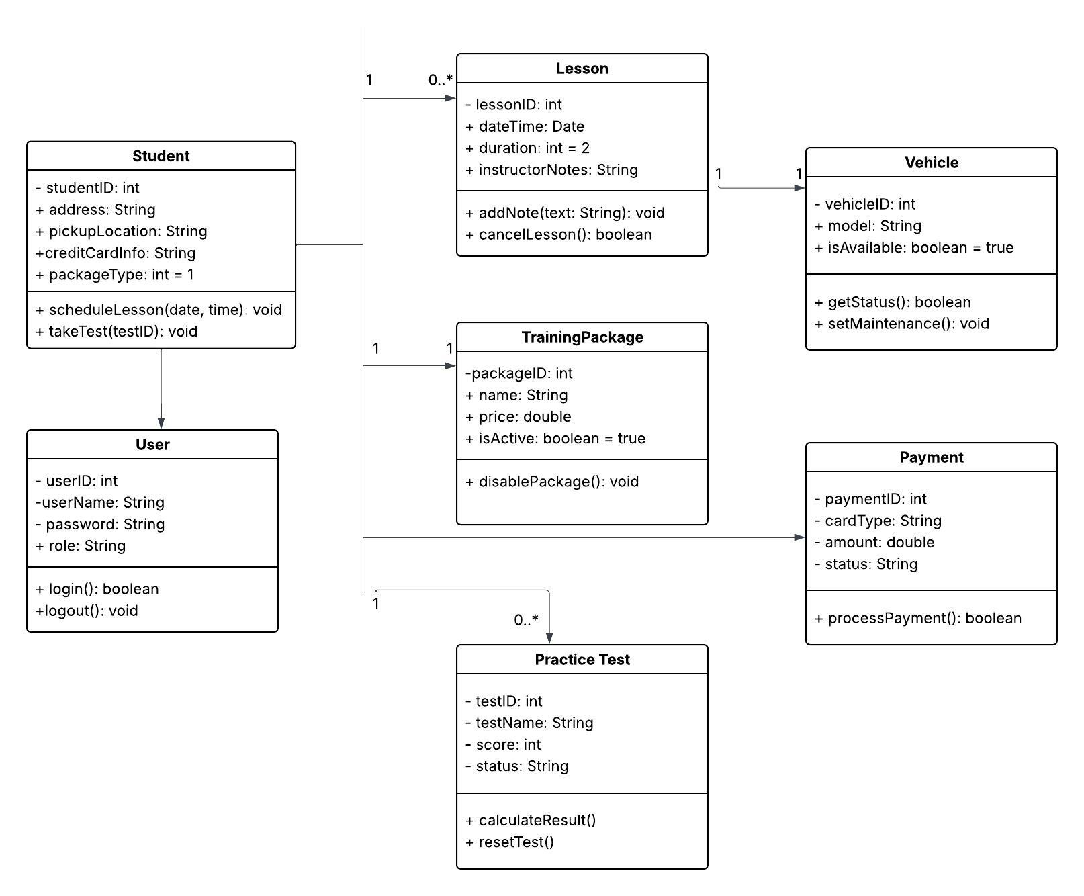

Technical Requirements
The DriverPass system will be hosted on a cloud-based infrastructure such as AWS or MS Azure. This removes the need for on-site servers and reduces maintenance costs, while supporting Ian’s requirements for off site backups and secure system management. Hosting in the cloud also ensures high availability, meaning the system can be accessed 24/7 by students, instructors, and admin staff from any location with an internet connection. This makes the platform reliable as the main hub for all DriverPass operations.

To support the business data needs, the system will use a relational database (SQL). This is necessary to properly manage lessons, students, payments, vehicles, and training packages while keeping data integrity. It also helps prevent scheduling conflicts such as double / over bookings a car or instructor for the same time slot. The database will act as the core storage system that keeps everything organized and connected.

On the front end, the system will use a web application framework, so it works smoothly across different devices like desktops, laptops, tablets, and mobile devices. This ensures both office staff and instructors can access the system without needing special hardware. Users will only need a modern web browser to interact with this platform.

Finally, the system will rely on key integrations and security protocols to function correctly. A secure API will be used for payment processing when students make a purchase. The system will also integrate with DMV updates to keep training materials and practice tests current with the latest rules and regulations. All sensitive data, including student info and payment details will be protected with encryption and role-based access. This ensures that only authorized users such as Ian and Liam can access Admin or financial sections.

